• Mayor Langfelder to propose residency requirement for city workers
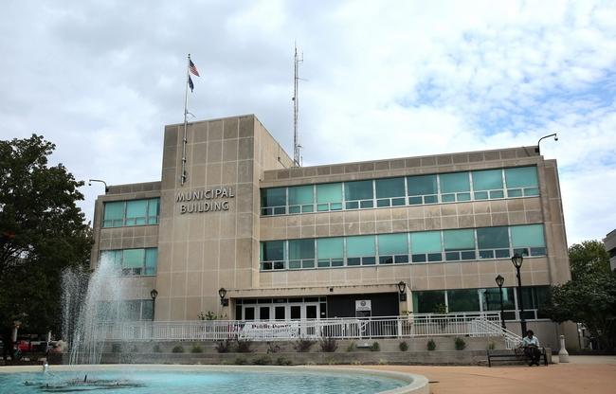|

Municipal Center West in Springfield seen on Thursday, Oct. 8, 2015. staff photo/The State Journal-Register

By Jamie Munks, Staff Writer
Posted Oct. 10, 2015 at 5:00 PM
Updated Oct 10, 2015 at 10:35 PM
With more than 30 percent Springfield city workers not having Springfield addresses, and some municipal employees commuting as far as 80 miles, Mayor Jim Langfelder is seeking to reinstitute a requirement that new hires live in the city.
A residency ordinance was still being drafted at city hall last week, but Langfelder said he favors an approach with a "grandfather clause" that would allow current employees who reside outside the city to stay where they are and require people hired after a certain date to move inside the corporate limits within six months.
"We want to draw a line in the sand, and anyone outside the city would be grandfathered in," Langfelder said. "But people within the city would need to stay within the city."
According to employment data provided by the city's human resources office last week in response to a Freedom of Information Act request, 443 of the city's 1,430 workers don't have Springfield addresses.
The data doesn't separate out people who have Springfield mailing addresses but don't live within the city's official boundaries. So the total number of employees residing outside city boundaries is higher than 443.
There's been some debate in the past about whether residents of Jerome, Leland Grove, Grandview and Southern View would be considered part of Springfield. In Langfelder's proposal, they won't, he said.
Residency rules in Springfield, which have been passed and repealed by different city councils over the years, have stoked passionate debates inside the council chamber. Opponents have argued that residency requirements go too far, while proponents counter that they can boost the local economy and that if the city is good enough to work for, it should be good enough to live in.
Sarah Rothert, who works in customer service in the City Water, Light and Power commercial office, said she lives in the city. But she wondered whether people who live outside Springfield and are contemplating applying for a municipal job might think twice because of a residency requirement.
"With how small the city is, it's easy for people to live outside," Rothert said. "I would think there would have to be a lot of questions answered."
Council divided
The Springfield City Council repealed a residency requirement in 2000 that had been enacted in 1976, allowing rank-and-file municipal workers to live outside the city. Elected officials and department directors were still required to live in Springfield, however.
The residency issue was rekindled three years ago, and 59 percent of voters in a nonbinding referendum favored requiring future employees to live in the city. But aldermen continued to be divided on the issue, and the last city council didn't pass an ordinance reinstituting the rule.
Ward 7 Ald. Joe McMenamin is strongly in favor of a residency requirement, and he urged fellow aldermen to look back at the results of the referendum in their wards and "vote the wishes of their constituents."
"It will strengthen our city neighborhoods and the financial picture for both city government and all our retail and commercial sales," McMenamin said.
Langfelder said he anticipates asking aldermen to re-enact a residency rule later this month or next, but questions about such a requirement linger among some of the city's 10 aldermen.
Ward 1 Ald. Chuck Redpath supported residency during his last stint on the city council, representing Ward 4. But he's not quite as comfortable with the proposal this time.
"I don't know that I'm on board with this one. I'm just concerned it's gotten to the point where it's too far," Redpath said of the many places city workers calls home. "What are we gaining?"
A residency requirement was one of the more widely discussed issues during the mayoral race earlier this year, when Langfelder defeated four other candidates. Langfelder, who served as city treasurer for 12 years prior to becoming mayor, said he has always been a residency proponent.
The city council under the Langfelder administration already has approved several collective bargaining agreements with unions representing city workers that include language addressing a possible future residency rule.
No detriment, firefighters say
Of all city departments, the Springfield Fire Department has the highest percentage of employees living outside the city — more than 45 percent, according to city employment figures.
The city's other three largest departments trail the fire department in the percentage of out-of-town workers. Thirty-two percent of CWLP employees, 30 percent of the police department and 27 percent of the public works department have non-Springfield addresses.
The city clerk's office and the mayor's office, both relatively small departments with five and 12 employees, respectively, have no employees with non-Springfield addresses. Five of the 12 employees at the Springfield Convention and Visitors Bureau have non-Springfield addresses.
The firefighters union lobbied heavily for the repeal of the residency requirement before it was passed in 2000.
The city's been without a residency requirement for a decade and a half, which hasn't had a negative effect on the dedication of fire department employees or the services delivered to residents, said Gary Self, the union's president.
"Not having residency doesn't have a detrimental effect on the department," Self said.
The firefighters union contract expires Feb. 28, and Self anticipates negotiations for a new contract will begin by the end of this year.
Firefighters who are coming on at the department take a test and receive points if they're city residents or veterans, Springfield Fire Chief Barry Helmerichs said.
The higher percentage of fire department employees living outside of the city compared with other departments is likely due to the shift differences. Other city employees typically come to work five days a week. Fire department employees typically report to work every third day and stay for 24 hours.
While more than 45 percent of fire department employees don't have Springfield addresses, many of those employees are living in surrounding communities such as Chatham, Sherman and Rochester, Helmerichs said.
"I don't think it would have an effect on us," Helmerichs said of a residency requirement.
A total of 14 city employees have one-way commutes to work of more than 60 miles, according to city data. Of those 14, the fire department has eight, Lincoln Library and CWLP each have two, and the police and public works departments each have one.
